**Programming Assignment-2**

**Merge Sort and Quick sort Observations**

The program for implementing Merge Sort and quick Sort are Observed

**Merge Sort averaging table** :

Sorted Array,

For n=1000;

|  |  |
| --- | --- |
| Attempt number for, N=1000 | Time to sort the array (s) |
| 1 | 0.0012 |
| 2 | 0.0020 |
| 3 | 0.0017 |
| 4 | 0.0018 |

Average value= 0.001675

**Merge Sort averaging table:**

Sorted Array,

For n=2000,

|  |  |
| --- | --- |
| Attempt number for, N=2000 | Time to sort the array (s) |
| 1 | 0.002 |
| 2 | 0.003 |
| 3 | 0.0025 |
| 4 | 0.0020 |

Average value= 0.002375

**Merge Sort averaging table:**

Sorted Array,

For n=3000,

|  |  |
| --- | --- |
| Attempt number for, N=3000 | Time to sort the array (s) |
| 1 | 0.0030 |
| 2 | 0.0028 |
| 3 | 0.0033 |
| 4 | 0.0034 |

Average value= 0.003125

**Merge Sort averaging table:**

Sorted Array,

For n=4000,

|  |  |
| --- | --- |
| Attempt number for, N=4000 | Time to sort the array (s) |
| 1 | 0.0040 |
| 2 | 0.0038 |
| 3 | 0.0037 |
| 4 | 0.0038 |

Average value= 0.003825

**Practical graph from observations**

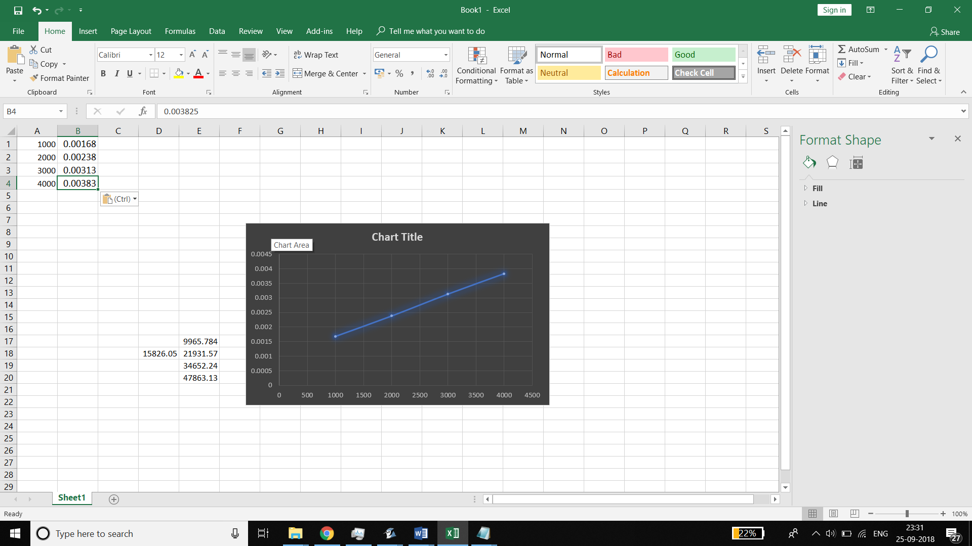

**Theoretical calculation of n(logn)**

**Quick sort averaging table:**

Sorted Array,

For n=1000

|  |  |
| --- | --- |
| Attempt number for, N=1000 | Time to sort the array (s) |
| 1 | 0.0020 |
| 2 | 0.0010 |
| 3 | 0.0010 |
| 4 | 0.0010 |

Average value = 0.00125

**Quick sort averaging table:**

Sorted Array,

For n=2000

|  |  |
| --- | --- |
| Attempt number for, N=2000 | Time to sort the array (s) |
| 1 | 0.0040 |
| 2 | 0.0040 |
| 3 | 0.0050 |
| 4 | 0.0040 |

Average value = 0.00425

**Quick sort averaging table:**

Sorted Array,

For n=3000

|  |  |
| --- | --- |
| Attempt number for, N=3000 | Time to sort the array (s) |
| 1 | 0.0100 |
| 2 | 0.0080 |
| 3 | 0.0140 |
| 4 | 0.0090 |

Average value = 0.01025

**Quick sort averaging table:**

Sorted Array,

For n=4000

|  |  |
| --- | --- |
| Attempt number for, N=4000 | Time to sort the array (s) |
| 1 | 0.0150 |
| 2 | 0.0150 |
| 3 | 0.0180 |
| 4 | 0.0140 |

Average value = 0.0155

**Practical obsevation**

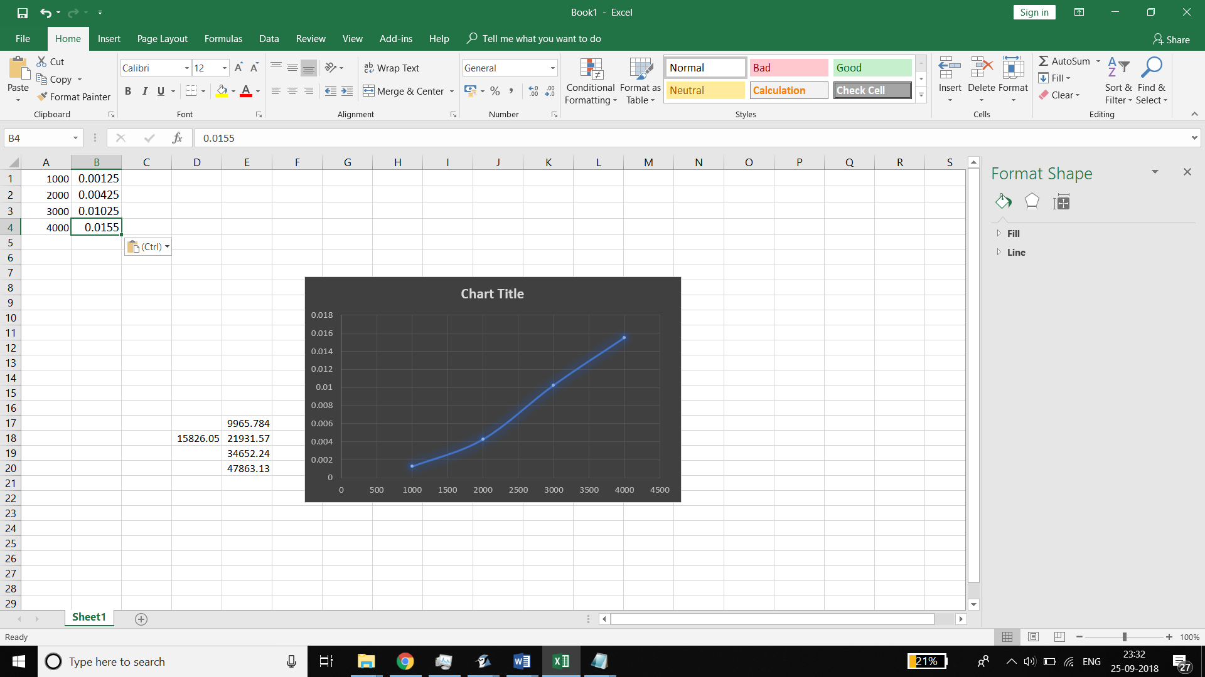

**Theoretical analysis n(log n)**

Conclusion :

From the above observations it can be concluded that it is similar to the theoretical obsevations and hence the code is verified to be correct.